**Year 11 Essentials 2020**

**Practical Assessment 1**

# Estimating Area and Volume

**Name:** _________________________________

Time for the task: 1 week

Resources needed – 4 metre ruler or tape measure **Total Marks:** / 15

**Task weighting:** 12.5%

**Due Date:** ________________________________

It takes practice to become good at estimating. You will complete the following practical estimation activities to develop your estimation skills. Use the record sheet below to record your estimates for the five activities on the following pages.

**Record Sheet**

|  |  |  |  |
| --- | --- | --- | --- |
| **Activity** | **Your Estimate** | **Real Measurement** | **Difference in Measurement** |
| Number of footprints in a square metre |  |  |  |
| Number of handprints in a square metre |  |  |  |
| Area of a car numberplate in square centimetres |  |  |  |
| Volume of a car boot in cubic metres |  |  |  |
| Volume of a car in cubic metres |  |  |  |

|  |
| --- |
| **Activity 1: Footprints in a square metre** |

Imagine you are going to cover a square metre with your footprints.

How many footprints will fit inside 1 m2 without any overlaps?

Record your estimate on the record sheet.

How good was your estimate, record the actual answer.

1. 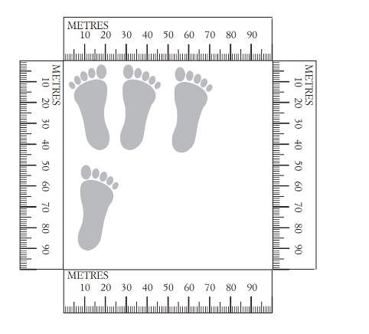Put a piece of paper under your foot and trace around the outside to make a template of your foot. Use scissors to cut out the template. Make several templates.
2. Place four 1-metre rulers on the floor to outline an area of 1 m2 or use duct tape to make a 1 by 1 metre square on the carpet.
3. Systematically place your foot template in the 1 m2 and check your estimate by counting the number required to cover the square.

|  |
| --- |
| **Activity 2: Handprints in a square metre** |

Now imagine you are going to cover a square metre with your handprints, without any overlaps.

How many handprints will you need?

Use a similar method to that used for checking the number of footprints in a square metre, to check the accuracy of your handprint estimates.

|  |
| --- |
| **Activity 3: The area of a car numberplate** |

Estimate the area covered by a car numberplate. To check your estimate, measure the length and the width of an appropriate numberplate, then calculate the area using the formula:

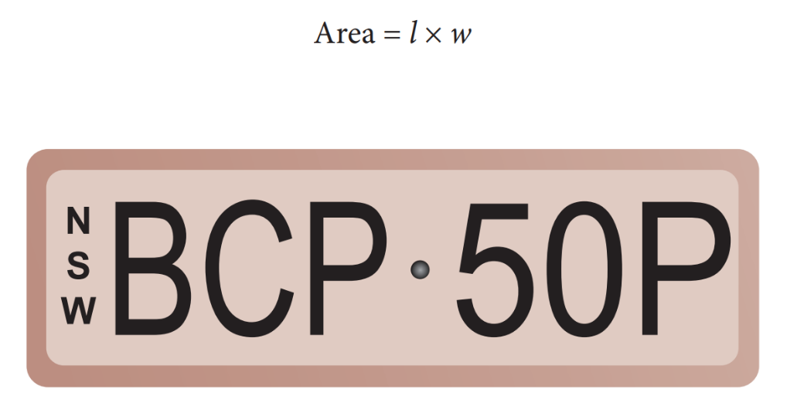

|  |
| --- |
| **Activity 4: The volume of a car boot** |

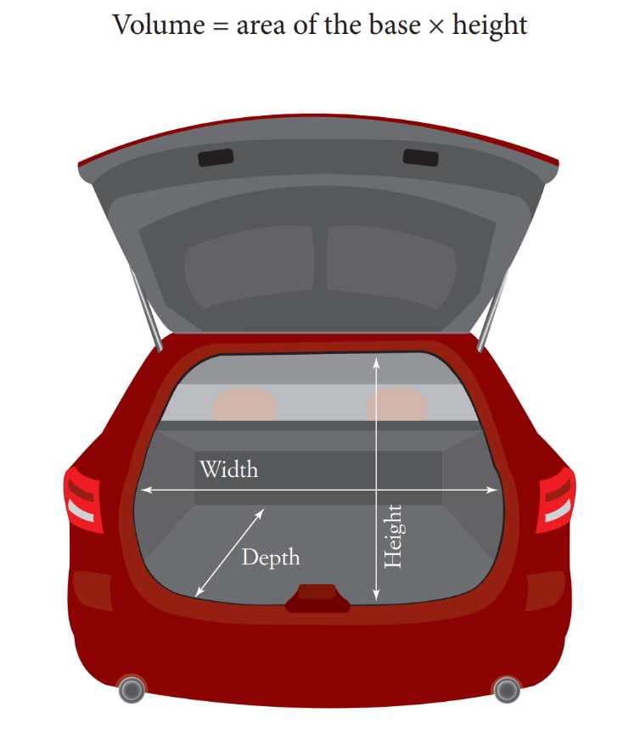Luggage compartments of cars come in different sizes. Before you start this activity, select an appropriate car. Record your estimate for the volume, then measure the width, depth and height of the car boot in metres. Calculate the volume in m3 using the formula:

|  |
| --- |
| **Activity 5: The volume of a car** |

The volume of most cars can be modelled by using two or three rectangular prisms: the engine, the main body and the boot. Before your group starts this activity, select an appropriate car.

Record the estimates then measure the width, depth and height of the sections of the car in metres.

Calculate the volume of each section, in m3, using the formula: Volume = area of the base × height

Then add the volumes of the sections to determine the total volume.

